1**) Write a program to set up or configure REST assured.**

Development Environment:

● Java 1.8

● Eclipse

● TestNG

● Maven

This guide has three subsections, namely:

3.1.1 Creating a Maven project in Eclipse

3.1.2 Updating the pom.xml file with the latest stable REST Assured dependencies

3.1.3 Pushing the code to GitHub repositories

Step 3.1.1: Creating a Maven project in Eclipse

REST Assured is an API designed for automating REST services or REST APIs.

● Open Eclipse.

● Click on File---> click on New--->Project.

● Select the Maven project and click on Next.

● Enter the Group id, Artifact id, and click on Finish.

● Right click on Project---> src/test/java---> Package.

● Enter the package name and click on Finish.

● Right click on Package---> New---> Class.

● Enter the class name and click on Finish.

Step 3.1.2: Updating the pom.xml file with the latest stable REST Assured dependencies

● Open the pom.xml file.

● Go to a browser and search for Maven repository.

● Add the dependencies to the pom.xml file, after adding all the dependencies the pom.xml file will look like this:

<dependencies>

<!-- https://mvnrepository.com/artifact/io.rest-assured/rest-assured -->

<dependency>

<groupId>io.rest-assured</groupId>

<artifactId>rest-assured</artifactId>

<version>3.3.0</version>

<scope>test</scope>

</dependency>

<!-- https://mvnrepository.com/artifact/org.testng/testng -->

<dependency>

<groupId>org.testng</groupId>

<artifactId>testng</artifactId>

<version>6.14.3</version>

<scope>test</scope>

</dependency>

<!-- https://mvnrepository.com/artifact/com.googlecode.json-simple/json-simple -->

<dependency>

<groupId>com.googlecode.json-simple</groupId>

<artifactId>json-simple</artifactId>

<version>1.1.1</version>

</dependency>

<!-- https://mvnrepository.com/artifact/org.apache.poi/poi -->

<dependency>

<groupId>org.apache.poi</groupId>

<artifactId>poi</artifactId>

<version>4.1.0</version>

</dependency>

<!-- https://mvnrepository.com/artifact/org.apache.poi/poi-ooxml -->

<dependency>

<groupId>org.apache.poi</groupId>

<artifactId>poi-ooxml</artifactId>

<version>4.1.0</version>

</dependency>

<!-- https://mvnrepository.com/artifact/io.cucumber/cucumber-java -->

<dependency>

<groupId>io.cucumber</groupId>

<artifactId>cucumber-java</artifactId>

<version>2.0.0</version>

</dependency>

<!-- https://mvnrepository.com/artifact/io.cucumber/cucumber-junit -->

<dependency>

<groupId>io.cucumber</groupId>

<artifactId>cucumber-junit</artifactId>

<version>2.0.0</version>

<scope>test</scope>

</dependency>

<!-- https://mvnrepository.com/artifact/info.cukes/gherkin -->

<dependency>

<groupId>info.cukes</groupId>

<artifactId>gherkin</artifactId>

<version>2.12.2</version>

<scope>provided</scope>

</dependency>

<!-- https://mvnrepository.com/artifact/info.cukes/cucumber-jvm-deps -->

<dependency>

<groupId>info.cukes</groupId>

<artifactId>cucumber-jvm-deps</artifactId>

<version>1.0.5</version>

<scope>provided</scope>

</dependency>

<!-- https://mvnrepository.com/artifact/io.cucumber/cucumber-jvm -->

<dependency>

<groupId>io.cucumber</groupId>

<artifactId>cucumber-jvm</artifactId>

<version>2.0.0</version>

<type>pom</type>

</dependency>

<!-- https://mvnrepository.com/artifact/net.masterthought/cucumber-reporting -->

<dependency>

<groupId>net.masterthought</groupId>

<artifactId>cucumber-reporting</artifactId>

<version>1.0.0</version>

</dependency>

<!-- https://mvnrepository.com/artifact/org.seleniumhq.selenium/selenium-java -->

<dependency>

<groupId>org.seleniumhq.selenium</groupId>

<artifactId>selenium-java</artifactId>

<version>3.5.3</version>

</dependency><!-- https://mvnrepository.com/artifact/junit/junit -->

<dependency>

<groupId>junit</groupId>

<artifactId>junit</artifactId>

<version>3.8.1</version>

<scope>test</scope>

</dependency>

<!-- https://mvnrepository.com/artifact/org.apache.logging.log4j/log4j-core -->

<dependency>

<groupId>org.apache.logging.log4j</groupId>

<artifactId>log4j-core</artifactId>

<version>2.12.1</version>

</dependency>

<!-- https://mvnrepository.com/artifact/io.rest-assured/json-schema-validator -->

<dependency>

<groupId>io.rest-assured</groupId>

<artifactId>json-schema-validator</artifactId>

<version>4.1.2</version>

</dependency>

<!-- https://mvnrepository.com/artifact/io.rest-assured/json-path -->

<dependency>

<groupId>io.rest-assured</groupId>

<artifactId>json-path</artifactId>

<version>4.1.1</version>

</dependency>

<!-- https://mvnrepository.com/artifact/org.hamcrest/java-hamcrest -->

<dependency>

<groupId>org.hamcrest</groupId>

<artifactId>java-hamcrest</artifactId>

<version>2.0.0.0</version>

<scope>test</scope>

</dependency>

<!-- https://mvnrepository.com/artifact/org.hamcrest/hamcrest-core -->

<dependency>

<groupId>org.hamcrest</groupId>

<artifactId>hamcrest-core</artifactId>

<version>2.2-rc1</version>

<scope>test</scope>

</dependency>

<!-- https://mvnrepository.com/artifact/org.hamcrest/hamcrest-library -->

<dependency>

<groupId>org.hamcrest</groupId>

<artifactId>hamcrest-library</artifactId>

<version>2.2-rc1</version>

<scope>test</scope>

</dependency>

<dependency>

<groupId>org.codehaus.groovy</groupId>

<artifactId>groovy-all</artifactId>

<version>2.4.5</version>

</dependency>

<!-- https://mvnrepository.com/artifact/io.rest-assured/xml-path -->

<dependency>

<groupId>io.rest-assured</groupId>

<artifactId>xml-path</artifactId>

<version>3.0.0</version>

</dependency>

</dependencies>

2) Write a program to demonstrate automation of GET request and response.

**Development Environment:**

* Java 1.8
* Eclipse
* TestNG
* Maven

This guide has three subsections, namely:

3.2.1 Creating a Maven project in Eclipse

3.2.2 Executing the GET request and response program

3.2.3 Pushing the code to GitHub repositories

**Step 3.2.1:** Creating a Maven project in Eclipse

Get Method: Get method is used to retrieve data from the server at the specified resource.

* Open Eclipse.
* Click on file ---> click on New ---> Project.
* Select the Maven project and click on Next.
* Enter the Group id, Artifact id, and click on Finish.
* Right click on Project---> src/test/java---> Package.
* Enter the package name and click Finish.
* Right click on Package---> New---> Class.
* Enter the class name and click Finish.
* Add dependencies to pom.xml file.

**Step 3.2.2:** Executing the GET request and response program

* Write the program GET request using REST Assured and click on Save.

**package** GetResponse;

import org.testng.annotations.Test;

import io.restassured.RestAssured;

import io.restassured.http.Method;

import io.restassured.response.Response;

import io.restassured.specification.RequestSpecification;

import junit.framework.Assert;

public **class** GetResponse1 {

@Test

void getempDetails()

{

//specify baseUrI

RestAssured.baseURI="http://192.168.1.207:8080/api/employee/search";

//Request object

RequestSpecification httpRequest=RestAssured.given();

//Response object

Response response=httpRequest.request(Method.GET,"/8095393564");

//print response in console window

String responseBody=response.getBody().asString();

         System.out.println("Response Body is:" +responseBody);

//status code validation

int statusCode=response.getStatusCode();

System.out.println("status code is :"+statusCode);

Assert.assertEquals(200,statusCode);

}

}

* Click on run and check the output in TestNG.

[RemoteTestNG] detected TestNG version 6.14.3

Response Body is:{"empId":3,"empName":"Sumit Kumar","empAddress":"Bellandur","mobileNumber":8095393564,"department":"development","project":"Cervical cancer application","teamLead":"RamaKrishnan","salary":10000.0,"joiningDate":"24-06-19"}

status code is :200

PASSED: getempDetails

===============================================

Default test

Tests run: 1, Failures: 0, Skips: 0

===============================================

===============================================

Default suite

Total tests run: 1, Failures: 0, Skips: 0

===============================================

3) Write a program to demonstrate automation of POST request and response.

This guide has three subsections, namely:

3.3.1 Creating a Maven project in Eclipse

3.3.2 Executing the POST request and response program

3.3.3 Pushing the code to GitHub repositories

Step 3.3.1: Creating a Maven project in Eclipse

POST Request: POST requests are used to send data to the API server to create or update a resource. The data sent to the server is stored in the request body of the HTTP request.

● Open Eclipse.

● Click on File---> click on New--->Project.

● Select the Maven project and click on Next.

● Enter the Group id, Artifact id, and click on Finish.

● Right click on Project---> src/test/java---> Package.

● Enter the package name and click Finish.

● Right click on Package---> New---> Class.

● Enter the class name and click Finish.

● Add dependencies to the pom.xml file.

Step 3.3.2: Executing the POST request and response program

● Write the program POST request using REST Assured and click on Save.

package GetResponse;

import org.json.simple.JSONObject;

import org.testng.annotations.Test;

import io.restassured.RestAssured;

import io.restassured.http.Method;

import io.restassured.response.Response;

import io.restassured.specification.RequestSpecification;

import junit.framework.Assert;

public class PostResponse {

@Test

void RegistrationSuccessful()

{

//specify base URI

RestAssured.baseURI="http://192.168.1.207:8080/api/employee/";

//Request object

RequestSpecification httpRequest=RestAssured.given();

//contains the information in the json format

//Request payload sending along with post request

JSONObject requestParams=new JSONObject();

requestParams.put("empName","Lavanya");

requestParams.put("empAddress","Bomanahalli");

requestParams.put("mobileNumber","9900321102");

requestParams.put("department","testing");

requestParams.put("teamLead","Aruna");

requestParams.put("salary","10000");

requestParams.put("joiningDate","14-05-19");

httpRequest.header("Content-Type", "application/json");

httpRequest.body(requestParams.toJSONString());//attach above data to the request

//Response object

Response response=httpRequest.request(Method.POST,"/add");

//print response in console window

String responseBody=response.getBody().asString();

System.out.println("Response Body is:" +responseBody);

//status code validation

int statusCode=response.getStatusCode();

System.out.println("Status code is:" +statusCode);

Assert.assertEquals(200,statusCode);

}

}

● Click on run and check the output in TestNG.

[RemoteTestNG] detected TestNG version 6.14.3

Response Body is:58

Status code is:200

PASSED: RegistrationSuccessful

===============================================

Default test

Tests run: 1, Failures: 0, Skips: 0

===============================================

===============================================

Default suite

Total tests run: 1, Failures: 0, Skips: 0

===============================================

}

4) Write a program to send XML payload in REST assured, parse XML response in REST assured, parse JSON response in REST assured, and explore native logging of REST assured.

This guide has six subsections, namely:

3.4.1 Creating a Maven project in Eclipse

3.4.2 Sending XML Payload in REST Assured

3.4.3 Parsing XML Response in REST Assured

3.4.4 Parsing JSON Response in REST Assured

3.4.5 Exploring Native Logging of REST Assured

3.4.6 Pushing the code to GitHub repositories

**Step 3.4.1:** Creating a Maven project in Eclipse

* Open Eclipse.
* Click on File---> click on New--->Project.
* Select the Maven project and click on Next.
* Enter the Group id, Artifact id, and click on Finish.
* Right click on Project---> src/test/java---> Package.
* Enter the package name and click Finish.
* Right click on Package---> New---> Class.
* Enter the class name and click on Finish.
* Add dependencies to pom.xml file.

**Step 3.4.2:** Sending XML Payload in REST Assured

* Write the program for XML Payload in REST Assured and click on Save.

**package** Response;

import static io.restassured.RestAssured.given;

import org.hamcrest.Matchers;

import org.testng.Assert;

import org.testng.annotations.Test;

import io.restassured.http.ContentType;

import io.restassured.response.Response;

public **class** XMLResponse

{

@Test

public void post_xml_test() {

Response response = given().contentType(ContentType.XML).accept(ContentType.XML).body("<Employee>" +

"<empName>Lavanya Gowda</empName>" + "<empAddress>abc</empAddress>"

+ "<mobileNumber>1592211560</mobileNumber>" + "<department>abc</department>" + "<project>abc</project>"

+ "<teamLead>abc</teamLead>" + "<salary>10000</salary>" + "<joiningDate>11-10-19</joiningDate>"

+ "</Employee>").when().post("http://192.168.1.207:8080/api/employee/add/xml");

System.out.println("POST Response\n" + response.asString());

// tests

int statusCode = response.getStatusCode();

System.out.println("Status code is:" + statusCode);

Assert.assertEquals(200, statusCode);

}

}

* Click on run and check the output in TestNG

[RemoteTestNG] detected TestNG version 6.14.3

POST Response

78

Status code is:200

PASSED: post_xml_test

===============================================

Default test

Tests run: 1, Failures: 0, Skips: 0

===============================================

===============================================

Default suite

Total tests run: 1, Failures: 0, Skips: 0

===============================================

**Step 3.4.3:** Parsing XML Response in REST Assured

* Write the program for XML Response in REST Assured and click on Save.

**package** Response;

import org.testng.annotations.Test;

import org.testng.Assert;

import io.restassured.RestAssured;

import io.restassured.http.ContentType;

import io.restassured.response.Response;

import static io.restassured.RestAssured.*;

public **class** ParseXML

{

@Test

public void parse_xml_test() {

Response response = given().contentType(ContentType.XML).accept(ContentType.XML).body("<Employee>" +

"<empName>Lavanya Gowda</empName>" + "<empAddress>abc</empAddress>"

+ "<mobileNumber>1591111560</mobileNumber>" + "<department>abc</department>" + "<project>abc</project>"

+ "<teamLead>abc</teamLead>" + "<salary>10000</salary>" + "<joiningDate>11-10-19</joiningDate>"

+ "</Employee>").when().post("http://192.168.1.207:8080/api/employee/add/xml");

System.out.println("POST Response\n" + response.asString());

// tests

int statusCode = response.getStatusCode();

System.out.println("Status code is:" + statusCode);

Assert.assertEquals(200, statusCode);

}

}

* Click on run and check the output in TestNG.

[RemoteTestNG] detected TestNG version 6.14.3

POST Response

85

Status code is:200

PASSED: parse_xml_test

===============================================

Default test

Tests run: 1, Failures: 0, Skips: 0

===============================================

===============================================

Default suite

Total tests run: 1, Failures: 0, Skips: 0

**Step 3.4.4:** Parsing JSON Response in REST Assured

Write the program for Parse JSON Response in REST Assured and click on Save.

**package** Response;

import static org.testng.Assert.assertEquals;

import java.util.List;

import org.json.simple.JSONObject;

import org.testng.annotations.Test;

import io.restassured.RestAssured;

import io.restassured.http.Method;

import io.restassured.path.json.JsonPath;

import io.restassured.response.Response;

import io.restassured.specification.RequestSpecification;

import junit.framework.Assert;

public **class** JsonParse {

    @Test

    public void testJsonParsing() {

        //specify base URI

RestAssured.baseURI="http://192.168.1.207:8080/api/employee/";

//Request object

RequestSpecification httpRequest=RestAssured.given();

//contains the information in the json format

//Request payload sending along with post request

JSONObject requestParams=new JSONObject();

requestParams.put("empName","Lavanya");

requestParams.put("empAddress","Bomanahalli");

requestParams.put("mobileNumber","9109320002");

requestParams.put("department","testing");

requestParams.put("teamLead","Aruna");

requestParams.put("salary","10000");

requestParams.put("joiningDate","14-05-19");

httpRequest.header("Content-Type", "application/json");

httpRequest.body(requestParams.toJSONString());//attach above data to the request

//Response object

Response response=httpRequest.request(Method.POST,"/add");

//print response in console window

String responseBody=response.getBody().asString();

System.out.println("Response Body is:" +responseBody);

//status code validation

int statusCode=response.getStatusCode();

System.out.println("Status code is:" +statusCode);

Assert.assertEquals(200,statusCode);

}

}

* Click on run and check the output in TestNG.

[RemoteTestNG] detected TestNG version 6.14.3

Response Body is:81

Status code is:200

PASSED: testJsonParsing

===============================================

Default test

Tests run: 1, Failures: 0, Skips: 0

===============================================

===============================================

Default suite

Total tests run: 1, Failures: 0, Skips: 0

===============================================

**Step 3.4.5:** Exploring Native Logging of REST Assured

* Write the program for Native Logging of REST Assured and click on Save.

**package** Response;

import org.testng.annotations.Test;

import static io.restassured.RestAssured.given;

import static io.restassured.RestAssured.when;

public **class** Logging

{

@Test

public void testLogging1()

{

given().get("http://192.168.1.207:8080/employee/api/search/8970922880").

then()

//.log().headers();

//.log().body();

//.log().cookies();

.log().all();

}

//Logs only in case of errors

@Test

public void testLogging2()

{

given().

get("http://192.168.1.207:8080/employee/api").

then().

log().ifError();

}

//conditional logging

@Test

public void testLogging3()

{

given().

get("http://192.168.1.207:8080/employee/api/search/8970922880").

then().

log().ifStatusCodeIsEqualTo(200);

}

}

* Click on run and check the output in TestNG.

[RemoteTestNG] detected TestNG version 6.14.3

HTTP/1.1 404

Content-Type: application/hal+json;charset=UTF-8

Transfer-Encoding: chunked

Date: Fri, 11 Oct 2019 07:01:31 GMT

{

"timestamp": "2019-10-11T07:01:31.720+0000",

"status": 404,

"error": "Not Found",

"message": "No message available",

"path": "/employee/api/search/8970922880"

}

HTTP/1.1 404

Content-Type: application/hal+json;charset=UTF-8

Transfer-Encoding: chunked

Date: Fri, 11 Oct 2019 07:01:31 GMT

{

"timestamp": "2019-10-11T07:01:31.961+0000",

"status": 404,

"error": "Not Found",

"message": "No message available",

"path": "/employee/api"

}

PASSED: testLogging1

PASSED: testLogging2

PASSED: testLogging3

===============================================

Default test

Tests run: 3, Failures: 0, Skips: 0

===============================================

===============================================

Default suite

Total tests run: 3, Failures: 0, Skips: 0

===============================================

5) Write a program to demonstrate GET, POST, XML, and JSON in REST Assured.

Problem statement for GET, POST, XML, and JSON

* **Objective:** As a part of developing a functionality, get the list of employees in a particular organization based on the number of parameters passed.
* **Following requirements should be met for problem statement:**
* Create a Maven project.
* Create a JSON package inside the Maven project.
* Create a class inside the package.
* Create a method for GET, POST, and XML to validate the response code from API for using REST Assured.
* Create a JSON Object.
* Create an HTTP request.

**Step 3.1.2:** Solution for the problem statement

Write the program for GET request, POST request, and XML payload using REST API in REST Assured and click on Save.

package Response;

**import** **static** io.restassured.RestAssured.given;

**import** org.json.simple.JSONObject;

**import** org.testng.annotations.Test;

**import** io.restassured.RestAssured;

**import** io.restassured.http.ContentType;

**import** io.restassured.http.Method; **import** io.restassured.response.Response;

**import** io.restassured.specification.RequestSpecification;

**import** junit.framework.Assert;

public class PostResponse {

@Test

**void** RegistrationSuccessful()

{

//specify base URI

RestAssured.baseURI="http://192.168.1.207:8080/api/employee/";

//Request object

RequestSpecification httpRequest=RestAssured.given();

//contains the information in the json format

//Request payload sending along with post request

JSONObject requestParams=new JSONObject();

requestParams.put("empName","Lavanya");

requestParams.put("empAddress","Bomanahalli");

requestParams.put("mobileNumber","9119321102");

requestParams.put("department","testing");

requestParams.put("teamLead","Aruna");

requestParams.put("salary","10000");

requestParams.put("joiningDate","14-05-19");

httpRequest.header("Content-Type", "application/json");

httpRequest.body(requestParams.toJSONString());//attach above data to the request

//Response object

Response response=httpRequest.request(Method.POST,"/add");

//print response in console window

**String** responseBody=response.getBody().asString();

System.out.println("Response Body is:" +responseBody);

//status code validation

**int** statusCode=response.getStatusCode();

System.out.println("Status code is:" +statusCode);

Assert.assertEquals(200,statusCode);

}

@Test

**void** getempDetails()

{

//specify baseUrI

RestAssured.baseURI="http://192.168.1.207:8080/api/employee/search";

//Request object

RequestSpecification httpRequest=RestAssured.given();

//Response object

Response response=httpRequest.request(Method.GET,"/8970922880");

//print response in console window

**String** responseBody=response.getBody().asString();

System.out.println("Response Body is:" +responseBody);

//status code validation

**int** statusCode=response.getStatusCode();

System.out.println("status code is :"+statusCode);

Assert.assertEquals(200,statusCode);

}

@Test

public **void** post_xml_test() {

Response response = given().contentType(ContentType.XML).accept(ContentType.XML).body("<Employee>" +

"<empName>Lavanya Gowda</empName>" + "<empAddress>abc</empAddress>"

+ "<mobileNumber>1592210060</mobileNumber>" + "<department>abc</department>" + "<project>abc</project>"

+ "<teamLead>abc</teamLead>" + "<salary>10000</salary>" + "<joiningDate>11-10-19</joiningDate>"

+ "</Employee>").when().post("http://192.168.1.207:8080/api/employee/add/xml");

System.out.println("POST Response\n" + response.asString());

// tests

**int** statusCode = response.getStatusCode();

System.out.println("Status code is:" + statusCode);

Assert.assertEquals(200, statusCode);

}

}

* Click on run and check the output in TestNG.

[RemoteTestNG] detected TestNG version 6.14.3

Response Body is:88

Status code is:200

Response Body is:{"empId":5,"empName":"Lavanya Gowda","empAddress":"bomanahalii","mobileNumber":8970922880,"department":"testing","project":"Cervical cancer application","teamLead":"Aruna","salary":10000.0,"joiningDate":"14-05-19"}

status code is :200

POST Response

89

Status code is:200

PASSED: RegistrationSuccessful

PASSED: getempDetails

PASSED: post_xml_test

===============================================

Default test

Tests run: 3, Failures: 0, Skips: 0

===============================================

===============================================

Default suite

Total tests run: 3, Failures: 0, Skips: 0

===============================================

6) Write a program to demonstrate OAuth authorization in REST API using REST assured.

**:** Creating a Maven project in Eclipse

OAuth: OAuth is a protocol that allows a user to grant limited access to their resources on one site to another, without having to expose their credentials.

* Open Eclipse.
* Click on File---> click on New--->Project.
* Select the Maven project and click on Next.
* Enter the Group id, Artifact id and click on Finish.
* Right click on Project---> src/test/java---> Package.
* Enter the package name and click Finish.
* Right click on Package---> New---> Class.
* Enter the class name and click on Finish.
* Add dependencies to pom.xml file.

**Step 3.5.2:** Executing the program for OAuth Authorization in REST API using REST Assured

* Write the program for OAuth Authorization in REST API using REST Assured and click on Save.

**package** Response;

import org.testng.annotations.Test;

import io.restassured.RestAssured;

import io.restassured.response.Response;

public **class** Oauth {

@Test

public void OAuth()

{

Response resp=RestAssured.given()

.auth()

.oauth2("a2c46473d65826bb118e5ae7e260d4cf604c8e982")

.post("http://192.168.1.207:8080/api/employee/search/1597534560");

System.out.println("code" +resp.getStatusCode());

System.out.println("code" +resp.getBody().asString());

}

}

* Click on run and check the output in TestNG.

[RemoteTestNG] detected TestNG version 6.14.3

Body is:{"empId":5,"empName":"Lavanya Gowda","empAddress":"bomanahalii","mobileNumber":8970922880,"department":"testing","project":"Cervical cancer application","teamLead":"Aruna","salary":10000.0,"joiningDate":"14-05-19"}

status code is :200

PASSED: OAuth

===============================================

Default test

Tests run: 1, Failures: 0, Skips: 0

===============================================

===============================================

Default suite

Total tests run: 1, Failures: 0, Skips: 0

===============================================

7) Write a program to demonstrate SSL authentication.

● The project structure looks like the screenshot below:

● Open Eclipse.

● Click on File---> click on New--->Project.

● Select the Maven project and click on Next.

● Enter the Group id, Artifact id and click on Finish.

Step 3.6.2: Updating the pom.xml file with required dependencies

● Open the pom.xml file.

● Add the given dependencies to the pom.xml file.

<dependency>

<groupId>io.rest-assured</groupId>

<artifactId>rest-assured</artifactId>

<version>3.3.0</version>

<scope>test</scope></dependency>

<dependency>

<groupId>org.testng</groupId>

<artifactId>testng</artifactId>

<version>6.14.3</version>

<scope>test</scope></dependency>

Step 3.6.3: Handling SSLPeerUnverifiedException using REST Assured

● Create a package “com.employeeapi.testcases” inside the src/test/java directory.

● Create a class“SslAuthentication.java” inside the package “com.employeeapi.testcases”.

● Write the below code:

package com.employeeapi.testcases;

import org.testng.annotations.BeforeClass;

import org.testng.annotations.Test;

import static io.restassured.RestAssured.*;

import static org.hamcrest.Matchers.*;

import io.restassured.RestAssured;

public class SslAuthentication {

/*Suppose has invalid certificate and throwing an

SSLPeerUnverifiedException

* so to handle this case we can relax certificate condition and now SSL

Exception will not come

*

* Do not have any proper url to test this feature*/

@Test

public void testSsl() {

given().relaxedHTTPSValidation()

.when().get("http://www.bupa.com.au/")

.then().statusCode(200);

}

}

● Suppose the url has an invalid certificate then it will throw an SSLPeerUnverifiedException.

● To handle this case we can relax the certificate condition using relaxedHTTPSValidation() and then SSL Exception will not occur.

● Note: Do not have any proper url to test this feature.

● Right click on SSAuthentication class --> Run As --> TestNg Test.

● Verify the output from the Console:

● Note: testSsl is Passed.

8) Write a program to configure Log4j in Eclipse Maven project.

Creating a Maven Project

* Open Eclipse.
* Click on File---> New--->Project.
* Select the Maven project and click on Next.
* Enter the Group id and Artifact id and click on Finish.

**Step 3.7.2:** Updating the pom.xml file with log4j dependencies

* Open the pom.xml file.
* Add the dependencies given below to pom.xml file:

<dependency>

<groupId>log4j</groupId>

<artifactId>log4j</artifactId>

<version>1.2.17</version></dependency>

**Step 3.7.3:** Testing the application with BasicConfigurator

* Create a package **com.employeeapi** inside the src/main/java directory.
* Create a class **LogTest.java** inside the package **com.employeeapi.**
* Write the code given below to test the logger:

**package** com.employeeapi;

**import** org.apache.log4j.BasicConfigurator;

**import** org.apache.log4j.Logger;

**public** **class** LogTest {

**static** **final** **Logger** logger =

**Logger**.getLogger(LogTest.class);

**public** **static** void main(**String**[] args)

{

//Configure logger

BasicConfigurator.configure();

logger.debug("Hello World!");

}

}

* Run the Java application and verify the output.

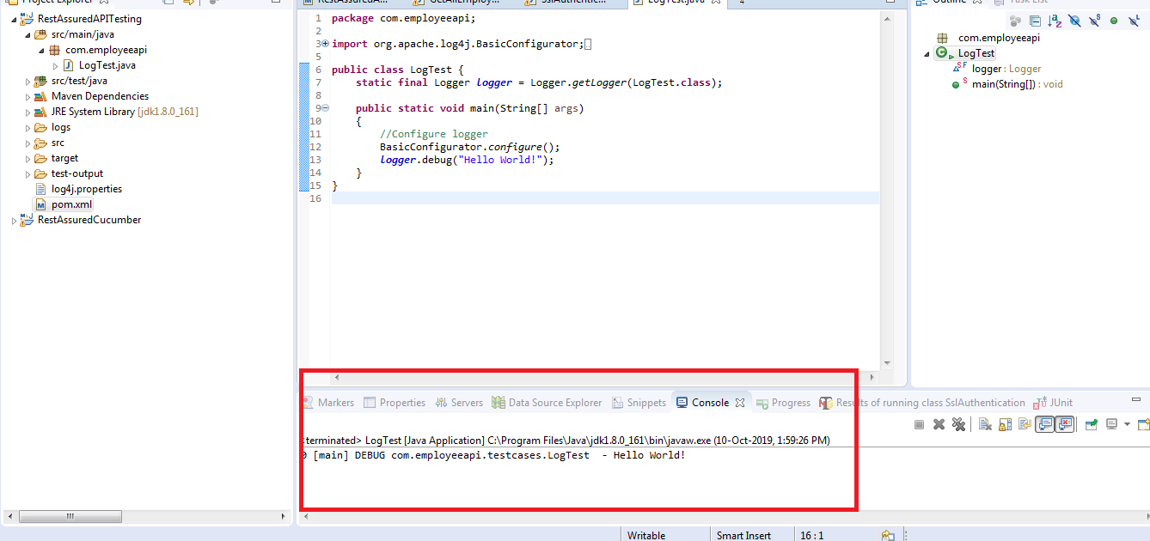

9) Write a program to generate logs on Eclipse Console using Log4j.

Creating a Maven project

3.9.2 Updating the pom.xml file with the required dependencies

3.9.3 Creating a log4j.properties file for RollingFileAppender

3.9.4 Testing the REST API using REST Assured and log4j

3.9.5 Pushing the code to GitHub repositories

**Step 3.9.1:** Creating a Maven project

* Open Eclipse.
* Click on File---> New--->Project.
* Select the Maven project and click on Next.
* Enter the Group id and Artifact id and click on Finish.

**Step 3.9.2:** Updating the pom.xml file with the required dependencies

* Open the pom.xml file.
* Add the dependencies given below to the pom.xml file:

<dependency>

<groupId>io.rest-assured</groupId>

<artifactId>rest-assured</artifactId>

<version>3.3.0</version>

<scope>test</scope

></dependency>

<dependency>

<groupId>org.testng</groupId>

<artifactId>testng</artifactId>

<version>6.14.3</version>

<scope>test</scope>

</dependency>

<dependency>

<groupId>log4j</groupId>

<artifactId>log4j</artifactId>

<version>1.2.17</version>

</dependency>

**Step 3.9.3:** Creating alog4j.properties file for RollingFileAppender

* Right click on Project --> New --> File.
* Name the file as **log4j.properties** and click on Finish.
* Open log4j.properties.
* Write the code given below:

# Root Logger option

log4j.rootLogger=INFO, file, stdout

# Direct log messages to a log file

log4j.appender.**file**=org.apache.log4j.RollingFileAppender

log4j.appender.**file**.**File**=${user.dir}/logs/restAPI.log

log4j.appender.**file**.MaxFileSize=10MB

log4j.appender.**file**.MaxBackupIndex=10

log4j.appender.**file**.layout=org.apache.log4j.PatternLayout

log4j.appender.**file**.layout.ConversionPattern=

%d{yyyy-MM-dd HH:mm:ss} %-5p %c{1}:%L %m%n

log4j.appender.**file**.Append=true

**Step 3.9.4:** Testing the REST API using REST Assured and log4j

* Create a package **com.employeeapi.base** inside the src/test/java directory.
* Create a class **TestBase.java** inside the package **com.employeeapi.base.**
* Write the code given below:

1. EmployeesRestAPI is the name given to logger.
2. Log4j.properties is the name of the file we created.

**package** com.employeeapi.base;

**import** org.apache.log4j.Level;

**import** org.apache.log4j.Logger;

**import** org.apache.log4j.PropertyConfigurator;

**import** org.testng.annotations.BeforeClass;

**import** io.restassured.response.Response;

**import** io.restassured.specification.RequestSpecification;

**public** **class** TestBase {

**public** **static** RequestSpecification httpRequest;

**public** **static** **Response** response;

**public** **String** empId="55123";

**public** **Logger** logger;

**@BeforeClass**

**public** void setup()

{

logger=**Logger**.getLogger("EmployeesRestAPI");

PropertyConfigurator.configure("Log4j.properties");

logger.setLevel(**Level**.DEBUG);

}

}

* Create a package **com.employeeapi.testcases** inside the src/test/java directory.
* Create a class **GetAllEmployees.java** inside the package **com.employeeapi.testcases.**
* Write the code given below:

**package** com.employeeapi.testcases;

**import** org.testng.Assert;

**import** org.testng.annotations.BeforeClass;

**import** org.testng.annotations.Test;

**import** com.employeeapi.base.TestBase;

**import** io.restassured.RestAssured;

**import** io.restassured.http.Method;

**import** io.restassured.response.ResponseBody;

**public** **class** GetAllEmployees **extends** TestBase{

**@BeforeClass**

void getAllEmployees() **throws** **InterruptedException** {

logger.info

("********statrt of GetAllEmployees class**********");

RestAssured.baseURI=

"http://192.168.1.207:8080/api/employee/search";

httpRequest = RestAssured.given();

response =

httpRequest.request(**Method**.GET,"/8095393564");

**Thread**.sleep(5000);

}

**@Test**

void checkResponseBody() {

logger.info

("*******Inside checkResponseBody*******");

**String** responseBody=response.getBody().asString();

logger.info("Response Body ==> "+responseBody);

Assert.assertTrue(responseBody!=**null**);

}

**@Test**

void checkStatusCode() {

logger.info("****Inside checkStatusCode*******");

int statusCode=response.getStatusCode();

logger.info("StatusCode ==>"+statusCode);

Assert.assertEquals(statusCode, 200);

}

**@Test**

void checkStatusLine() {

logger.info

("********Inside checkStatusLine*********");

**String** statusLine=response.getStatusLine();

logger.info("StatusLine ==>"+statusLine);

Assert.assertEquals(statusLine, "HTTP/1.1 200 ");

}

**@Test**

void checkContentType() {

logger.info

("********Inside checkContentType*********");

**String** contentType=response.header("Content-Type");

logger.info("Content type is ==>"+contentType);

Assert.assertEquals

(contentType, "application/json; charset=UTF-8");

}

}

* Right click on GetAllEmployees class --> Run As --> TestNG Test.
* Open restAPI.log file from logs folder and verify the output:

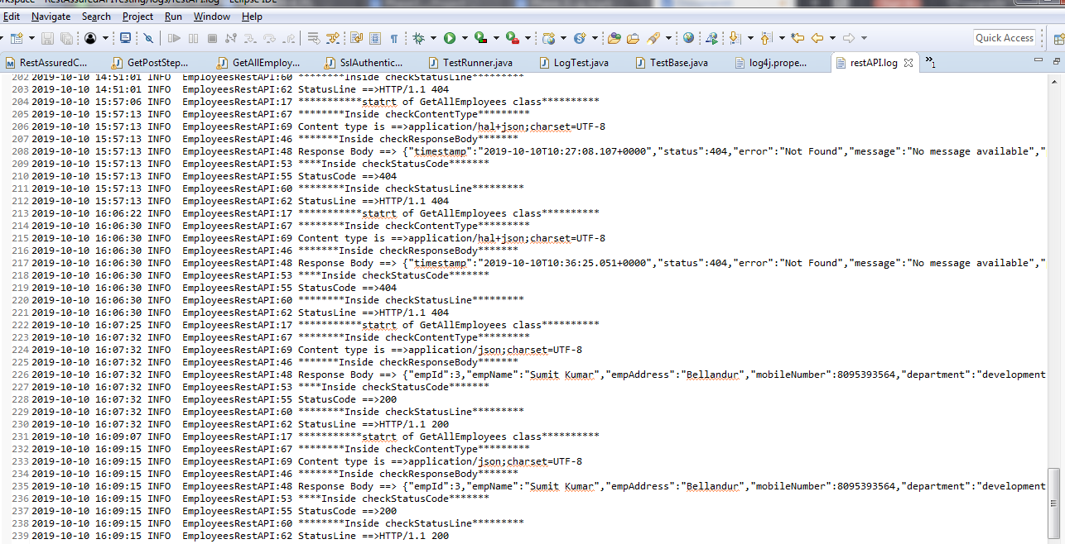

10) Write a program to write log file using Log4j.

Problem statement for OAuth, SSL, and Log4j

● Objective: Perform OAuth, SSL authentication for a given REST API, and track the execution using Log4j.

● Steps involved:

1. Create a Maven project.

2. Create class to write test cases.

3. Create a test method to handle SSLPeerUnverifiedException and to perform OAuth Authentication.

4. Include logger in the method.

Step 3.2.2: Solution for the problem statement

● The project structure looks like this:

● Open Eclipse.

● Click on file---> click on New--->Project.

● Select the Maven project and click on Next.

● Enter the Group id and Artifact id and click on Finish.

● Add the required dependencies to the pom.xml.

● Right click on Project --> New --> File.

● Name the file as “log4j.properties” and click on Finish.

● Open log4j.properties.

● Write the code shown below:

# Root Logger option

log4j.rootLogger=INFO, file, stdout

# Direct log messages to stdout

log4j.appender.stdout=org.apache.log4j.ConsoleAppender

log4j.appender.stdout.Target=System.out

log4j.appender.stdout.layout=

org.apache.log4j.PatternLayout

log4j.appender.stdout.layout.ConversionPattern=

%d{yyyy-MM-dd HH:mm:ss} %-5p %c{1}:%L %m%n

● Right click on project---> src/test/java---> Package.

● Enter the package name(Ex: com.employeeapi.testcases) and click on Finish.

● Right click on Package---> New---> Class.

● Enter the class name(Ex: OAuth) and click on Finish.

● Write a below code inside OAuth Class:

1. EmployeesRestAPI is the name given to logger.

2. Log4j.properties is the name of the file we created.

3. relaxedHTTPSValidation() is used to handle SSLPeerUnverifiedException.

4. “a2c46473d65826bb118e5ae7e260d4cf604c8e982” is the key.

package com.employeeapi.testcases;

import org.apache.log4j.Level;

import org.apache.log4j.Logger;

import org.apache.log4j.PropertyConfigurator;

import org.testng.annotations.BeforeClass;

import org.testng.annotations.Test;

import static io.restassured.RestAssured.*;

public class OAuth{

public Logger logger;

@BeforeClass

public void setup()

{

logger=Logger.getLogger("EmployeesRestAPI");

PropertyConfigurator.configure("Log4j.properties");

logger.setLevel(Level.DEBUG);

}

@Test

public void Oauth()

{

logger.info("***********statrt of OAuth

and SSLPeerUnverifiedException handling**********");

given().relaxedHTTPSValidation()

.auth()

.oauth2("a2c46473d65826bb118e5ae7e260d4cf604c8e982")

.post("http://192.168.1.207:8080/api/employee/search

/1597534560")

.then().statusCode(200);

logger.info("***********End of OAuth

and SSLPeerUnverifiedException handling**********");

}

}

● Right click on OAuth class --> Run As --> TestNG Test and verify the output in the console:

11) Write a program to demonstrate OAuth, SSL, and Log4j.

Problem statement for OAuth, SSL, and Log4j

* **Objective**: Perform OAuth, SSL authentication for a given REST API, and track the execution using Log4j.
* **Steps involved**:

1. Create a Maven project.
2. Create class to write test cases.
3. Create a test method to handle SSLPeerUnverifiedException and to perform OAuth Authentication.
4. Include logger in the method.

**Step 3.2.2:** Solution for the problem statement

* The project structure looks like this:

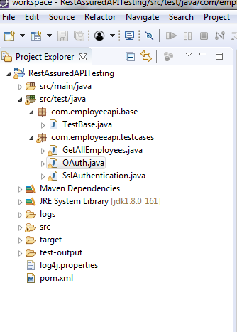

* Open Eclipse.
* Click on file---> click on New--->Project.
* Select the Maven project and click on Next.
* Enter the Group id and Artifact id and click on Finish.
* Add the required dependencies to the pom.xml.
* Right click on Project --> New --> File.
* Name the file as “log4j.properties” and click on Finish.
* Open log4j.properties.
* Write the code shown below:

# Root Logger option

log4j.rootLogger=INFO, file, stdout

# Direct log messages to stdout

log4j.appender.stdout=org.apache.log4j.ConsoleAppender

log4j.appender.stdout.Target=System.out

log4j.appender.stdout.layout=

org.apache.log4j.PatternLayout

log4j.appender.stdout.layout.ConversionPattern=

%d{yyyy-MM-dd HH:mm:ss} %-5p %c{1}:%L %m%n

* Right click on project---> src/test/java---> Package.
* Enter the package name(Ex: com.employeeapi.testcases) and click on Finish.
* Right click on Package---> New---> Class.
* Enter the class name(Ex: OAuth) and click on Finish.
* Write a below code inside OAuth Class:

1. EmployeesRestAPI is the name given to logger.
2. Log4j.properties is the name of the file we created.
3. relaxedHTTPSValidation() is used to handle SSLPeerUnverifiedException.
4. “a2c46473d65826bb118e5ae7e260d4cf604c8e982” is the key.

**package** com.employeeapi.testcases;

**import** org.apache.log4j.Level;

**import** org.apache.log4j.Logger;

**import** org.apache.log4j.PropertyConfigurator;

**import** org.testng.annotations.BeforeClass;

**import** org.testng.annotations.Test;

**import** **static** io.restassured.RestAssured.**\***;

**public** **class** OAuth{

**public** **Logger** logger;

**@BeforeClass**

**public** void setup()

{

logger=**Logger**.getLogger("EmployeesRestAPI");

PropertyConfigurator.configure("Log4j.properties");

logger.setLevel(**Level**.DEBUG);

}

**@Test**

**public** void Oauth()

{

logger.info("***********statrt of OAuth

and SSLPeerUnverifiedException handling**********");

given().relaxedHTTPSValidation()

.auth()

.oauth2("a2c46473d65826bb118e5ae7e260d4cf604c8e982")

.post("http://192.168.1.207:8080/api/employee/search

/1597534560")

.then().statusCode(200);

logger.info("***********End of OAuth

and SSLPeerUnverifiedException handling**********");

}

}

* Right click on OAuth class --> Run As --> TestNG Test and verify the output in the console:

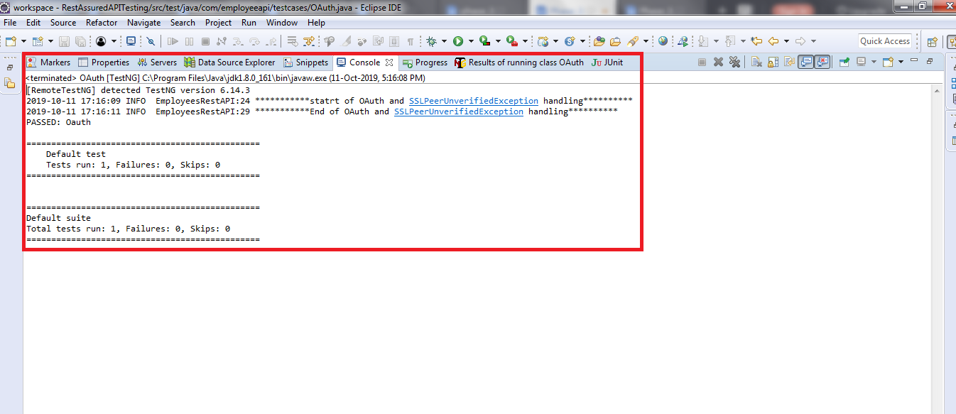

12) Write a program to implement BDD with REST assured using Cucumber.

Creating a Maven project

* Given below is the layout or example of a typical project structure:

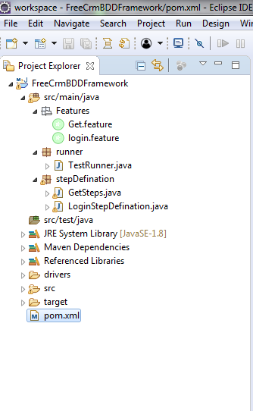

* Open Eclipse.
* Open Eclipse Marketplace and install Natural.
* Restart Eclipse.
* Click on File---> New--->Project.
* Select the Maven project and click on Next.
* Enter the groupId and artifactId and click on Finish.

**Step 3.10.2:** Updating the pom.xml file with the required dependencies

* Open the pom.xml file.
* Add the dependencies given below to the pom.xml file:

<dependency>

<groupId>io.rest-assured</groupId>

<artifactId>rest-assured</artifactId>

<version>3.3.0</version>

<scope>test</scope></dependency>

<dependency>

<groupId>io.cucumber</groupId>

<artifactId>cucumber-java</artifactId>

<version>2.0.0</version></dependency>

<dependency>

<groupId>io.cucumber</groupId>

<artifactId>cucumber-junit</artifactId>

<version>3.0.0</version>

<scope>test</scope></dependency>

<dependency>

<groupId>info.cukes</groupId>

<artifactId>gherkin</artifactId>

<version>2.12.2</version>

<scope>provided</scope></dependency>

<dependency>

<groupId>info.cukes</groupId>

<artifactId>cucumber-jvm-deps</artifactId>

<version>1.0.5</version>

<scope>provided</scope></dependency>

<dependency>

<groupId>io.cucumber</groupId>

<artifactId>cucumber-jvm</artifactId>

<version>2.0.0</version>

<type>pom</type></dependency>

<dependency>

<groupId>junit</groupId>

<artifactId>junit</artifactId>

<version>4.12</version>

<scope>test</scope></dependency>

**Step 3.10.3:** Testing an API BDD with REST Assured using Cucumber

* Create a package **Features** inside the src/main/java directory.
* Create a file **Get.feature** inside the package **Features.**
* Write the code given below:

Feature: Verify GET operation by BDD with Rest Assured **using**

Cucumber

Scenario: Verify Employee Details by Get Request

Given Perform get operation **for** employee

And Perform get **for** mobile number

Then Veriyfy the status code

* Create a package **stepDefination** inside the src/main/java directory.
* Create a class **GetSteps.java** inside the package **stepDefination.**
* Write the code given below:

**package** stepDefination;

**import** cucumber.api.java.en.And;

**import** cucumber.api.java.en.Given;

**import** cucumber.api.java.en.Then;

**import** io.restassured.http.ContentType;

**import** **static** io.restassured.RestAssured.**\***;

**public** **class** GetSteps {

**@Given("^Perform get operation for employee$")**

**public** void getMethod() {

given().contentType(ContentType.JSON);

}

**@And("^Perform get for mobile number$")**

**public** void getdata() {

when()

.get("http://192.168.1.207:8080/api/employee/search/8095393564")

.then().statusCode(200);

}

**@Then("^Veriyfy the status code$")**

**public** void checkstatus() {

}

}

* Create a package **runner** inside the src/main/java directory.
* Create a class **TestRunner.java** inside the package **runner.**
* Write the code given below:

1. features= “created feature file location”
2. glue={“stepDefination”} package name of “GetSteps.java” class

**package** runner;

**import** org.junit.runner.RunWith;

**import** cucumber.api.junit.Cucumber;

**import** cucumber.api.CucumberOptions;

**@RunWith(Cucumber.class)@CucumberOptions**

**(features="C:\\Users\\Prakat-Intern\\Desktop\\Cucumber\\**

**workspace\\FreeCrmBDDFramework\\src\\main\\java\\Features**

**\\Get.feature",**

**glue= {"stepDefination"})public** **class** TestRunner {

}

* Right click on TestRunner class --> Run As --> JUnit Test.
* Verify the output in the console.

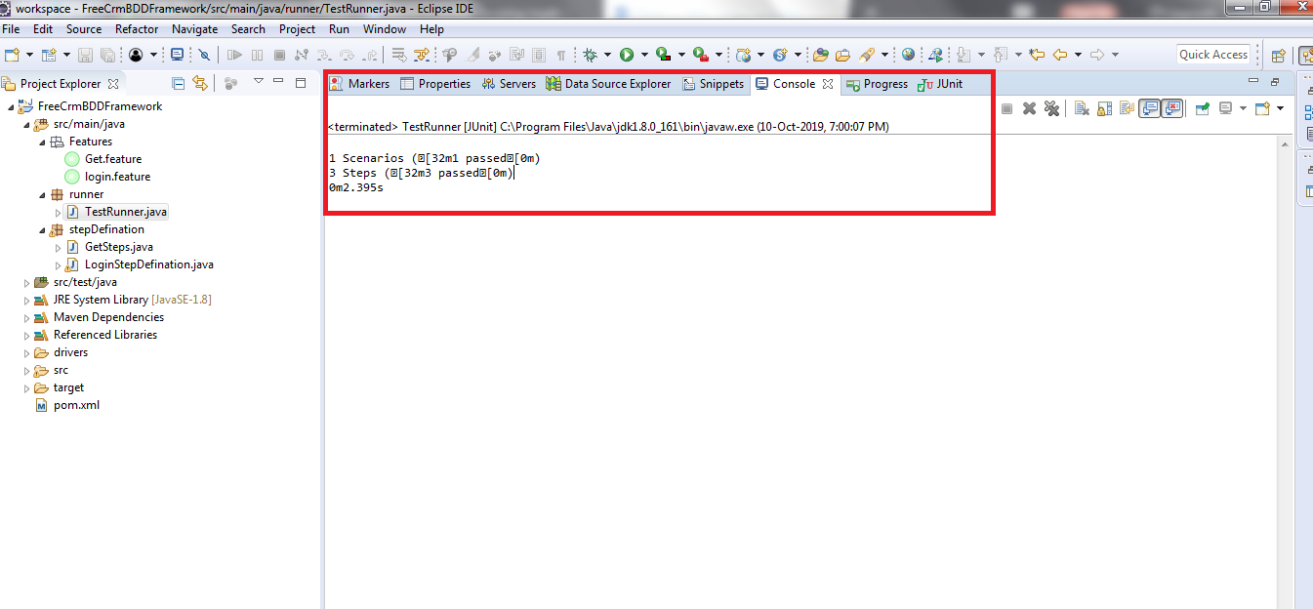

* Note: 1 Scenario and 3 steps are executed and all have passed.